**COCOA POWDER**

**HERO**

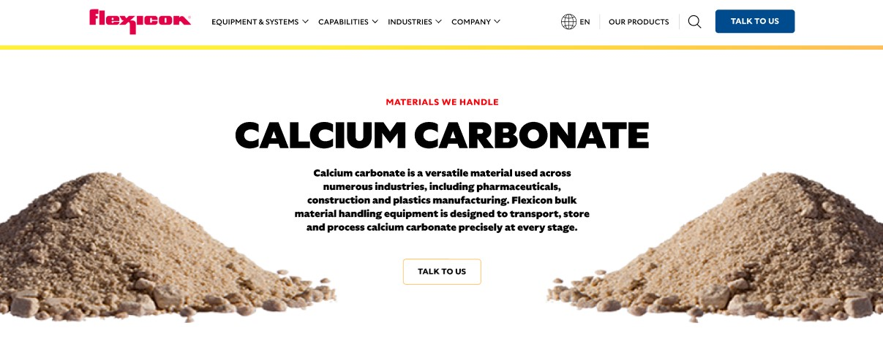

Cocoa powder is a fine, organic ingredient derived from roasted cocoa beans and widely used in food and confectionery. Flexicon’s bulk material handling equipment is engineered to convey, store, and process cocoa powder with precision.

**Button**: Talk To Us

**SHELF #1 - PRODUCT DESCRIPTION**

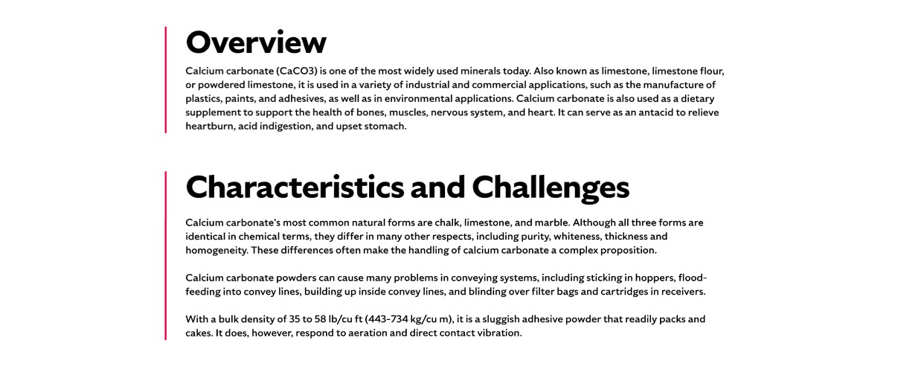

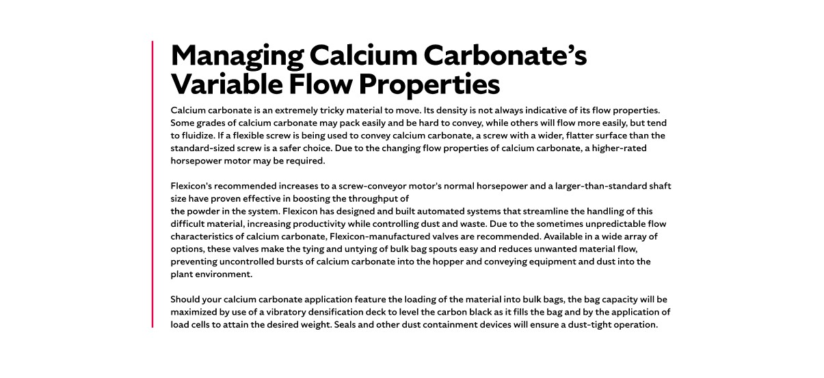

* **Overview**

Cocoa powder originates from the beans (seeds) of cacao trees, a tropical plant grown in Africa, southeast Asia, Hawaii, Brazil, and other countries where rainforest conditions exist. Cocoa powder is a key ingredient in chocolate, beverage mixes, bakery, dairy, and confectionary applications, valued for its flavor, color, and functional properties.

* **Characteristics and Challenges**

To retain its quality, cocoa powder must be stored cool, dry, and sealed to prevent moisture uptake, oxidation, or flavor loss. Flexicon equipment meets rigorous sanitary and dust-control standards, making it ideal for handling cocoa powder in food-grade environments.

Difficult to handle, cocoa powder cakes and packs easily and is hygroscopic - absorbing moisture and causing flow issues. Fine particles can fluidize and become airborne, leading to dust generation and density variations between batches. With its poor flow characteristics, cocoa powder will tend to "rat hole" or bridge in hoppers, completely blocking the flow of the material.

**SHELF #2 - FLEXICON SOLUTIONS**

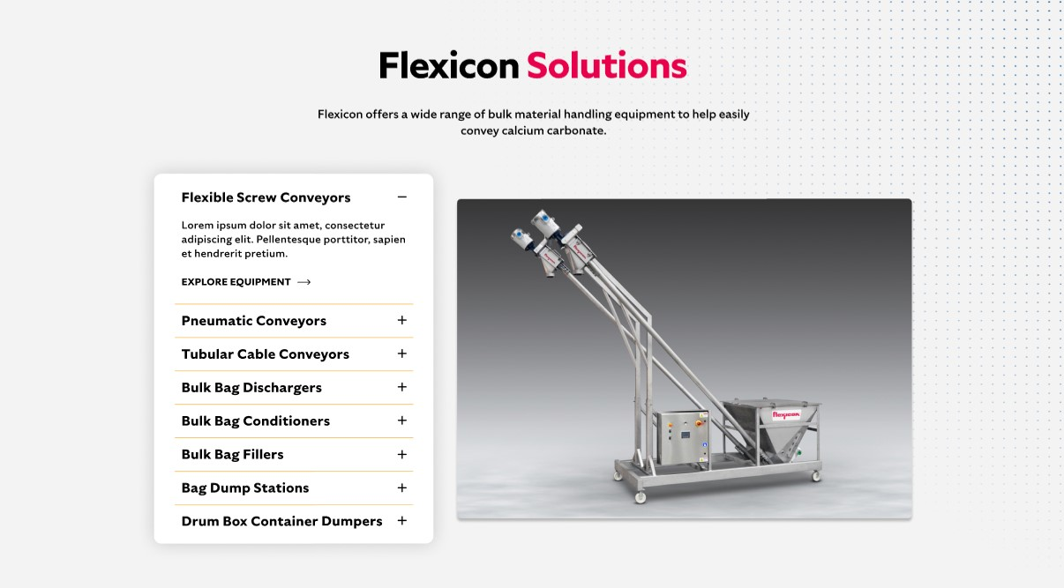

**Flexicon Solutions**

Flexicon offers a wide range of bulk material handling equipment to help easily convey cocoa powder.

* **Flexible Screw Conveyor:** Flexicon flexible screw conveyors gently transport fragile, hygroscopic cocoa powder without separation or compaction.
* **Pneumatic Conveyors:** Pneumatic conveyors move cocoa powder in a sealed, dust-tight stream, protecting product quality and environment.
* **Tubular Cable Conveyors:** Tubular cable conveyors offer a clean, flexible route for cocoa powder in restricted plant layouts.
* **Bulk Bag Dischargers:** Bulk bag dischargers unload cocoa powder with dust-tight spout connections and flow-promoting features.
* **Bulk Bag Conditioners:** Bulk bag conditioners loosen compacted cocoa powder in FIBCs to ensure consistent discharge.
* **Bulk Bag Fillers:** Bulk bag fillers accurately weigh and seal cocoa powder into bags, reducing dust, weight variance, and manual handling.
* **Bag Dump Stations:** Bag dump stations equipped with hoods and filtration allow clean manual unloading of cocoa powder from small bags.
* **Drum/Box/Container Dumpers:** Drum and box dumpers tip smaller containers to transfer cocoa powder into hoppers or conveyors with minimal dust.

**SHELF #3: LIFETIME PERFORMANCE GUARANTEE**



**Lifetime Performance Guarantee**

All Flexicon equipment and systems are backed by a lifetime performance guarantee. In the rare event that our product fails to meet your performance standards, we will provide the necessary repairs or replacements to keep your conveying line running.

**SHELF #4: CASE STUDIES**

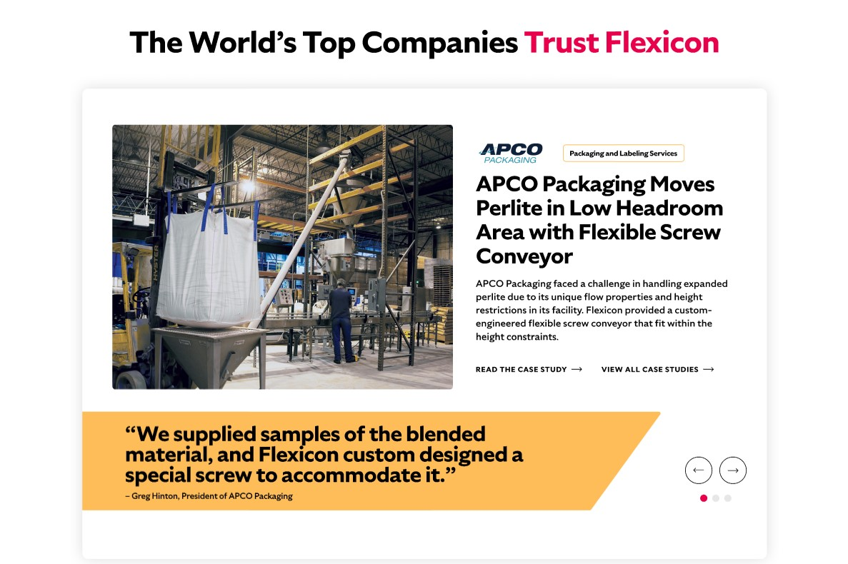

* If the cocoa powder arrives at the processing facility in bulk bags, the frames used to discharge the bags should ideally be equipped with additional accessories to completely empty the cocoa powder from the bag. This includes features such as spring-loaded frames that will stretch the bags as they empty and lighten, removing any residual accumulations of cocoa powder in the bags
* Bag activating devices are usually effective in loosening agglomerations of cocoa powder, promoting a better flow.
* A dust collector mounted on the discharger frame will contain the cocoa powder inside the conveyance system. Cocoa powder dust trapped in the filter media can be returned to the receiving hopper by a pneumatic pulse through the filter. This reduces waste and the time necessary to perform the routine cleaning and sanitation typically required in most food processing environments.
* If the cocoa powder is being added into the processing stream from smaller bags, a bag-breaking station with a dust hood, filtration devices and a pneumatic pulse cleaner is the recommended solution to support the manual unloading of the material. If empty bag disposal is an issue, a dust-tight bag compacting system may be necessary.
* feed hoppers should be designed with proper geometry and may need to incorporate devices such as mechanical agitators, vibrators or air fluidizers to promote flow. A hopper grate above the receiving vessel will help to prevent the introduction of foreign objects and protects the operators from any moving equipment inside the hoppers.
* If a flexible screw is being used to convey the cocoa powder, it is important to use a screw that matches the material's characteristics and other application requirements. Generally a screw with a wider, flatter surface than the standard-sized screw is necessary for this type of material.